Homework 2

电气58 wyz

3.2 Figure 3-10 is a single-phase full–wave controlled rectifier including a transformer with center tap, does this circuit including DC magnetic bias problem? Try to illustrate:

1. The Maximum forward to reverse voltage the thyristor can stand is.
2. When the load is a resistor or an inductor, the rectifier's output voltage and current waveform are the same with those of a single phase bridge full-controlled rectifier.



Figure 3-10 Single-phase full–wave controlled rectifier

**(This figure is also shown on slide 13, chapter 3 in Lecture Notes )**

**3.2 answer:**

It’s doesn’t exist DC magnetic bias problem because the average current of a full period in the single-phase full–wave controlled rectifier equals to zero.

(1). When the VT1 is on, the current goes B-C and the Uab=Ubc=, so those two voltage add to  to the VT2 and this situation is the maximum forward reverse voltage.

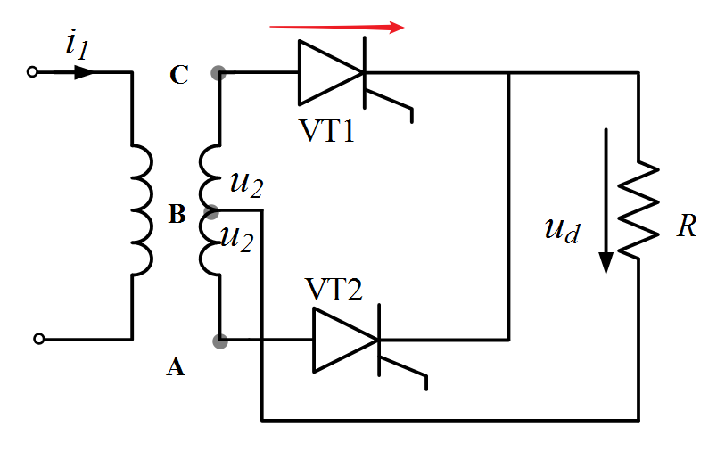

(2). single phase bridge full-controlled rectifier is A and the single-phase full–wave controlled rectifier is B.

1. When the firing anglebetween A and B is equal and the load is resistance:

,because the thyristor is off.

,because : for A, the VT1 is on; for B, VT1 and VT4 are on.

, because the thyristor is off.

, because : for A, the VT2 is on; for B, VT2 and VT3 are on.

1. When the firing anglebetween A and B is equal and the load is inductor:

,because : for A, the VT1 is on; for B, VT1 and VT4 are on.

, because : for A, the VT2 is on; for B, VT2 and VT3 are on.

3.3 To a single-phase bridge full-controlled rectifier, U2=100V, R=2Ω， L is extremely large, when α = 30°, try to:

1. Draw waveform of ***ud***, ***id*** and ***i2***.
2. Compute the rectifier's output average voltage ***Ud***, current ***Id***and RMS value of ***I2*** .
3. Considering safety margin, calculate the thyristor's ratio voltage and current.

**(The circuit for 3.3 is shown on slide 10, chapter 3 in Lecture Notes )**

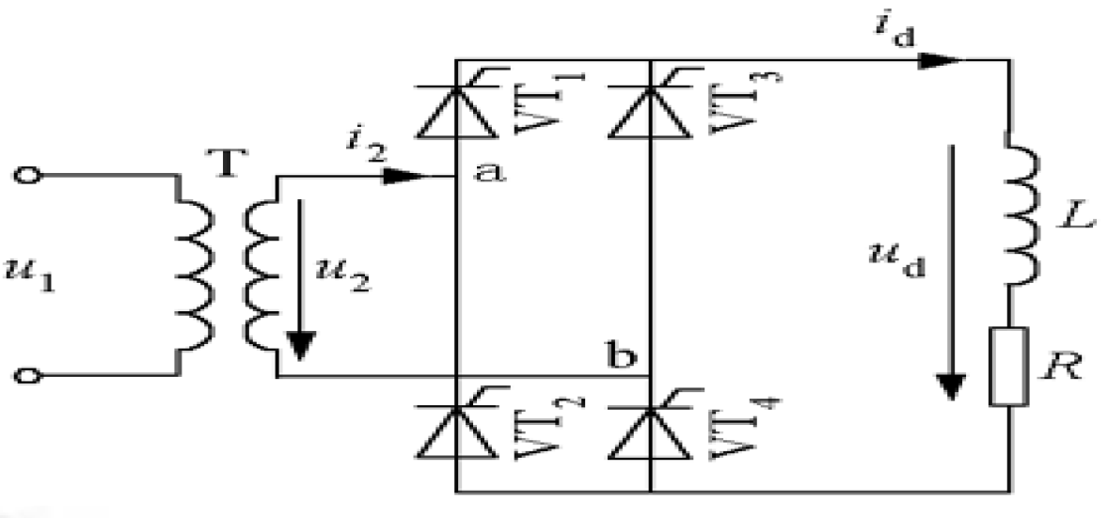

(1).Draw the waveform

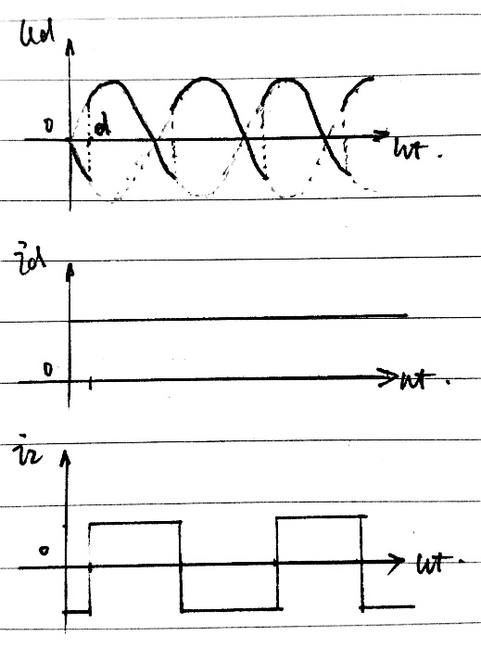

(2).Compute



(3).Ratio voltage and current

As we all know, the ratio voltage and current for the thyristor are larger than the maximum V and I it can stand. As usual, the time of ratio voltage to the maximum V is 2~3, and for the current is 1.5~2.

So :



3.5 To a single-phase bridge full-controlled rectifier, U2=200V, R=2Ω, L is extremely large, reverse electrical potential E = 100V, when α = 45°, try to:

1. Draw waveform of ***ud***, ***id*** and ***i2***.
2. Compute the rectifier's output average voltage ***Ud***, current ***Id***and RMS value of ***I2*** .
3. Considering safety margin, calculate the thyristor's rated voltage and current.

(1).

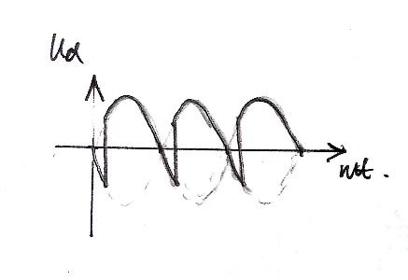

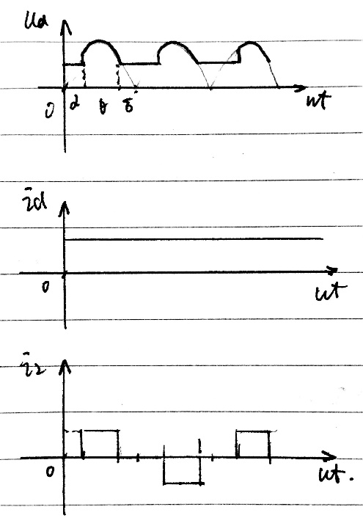

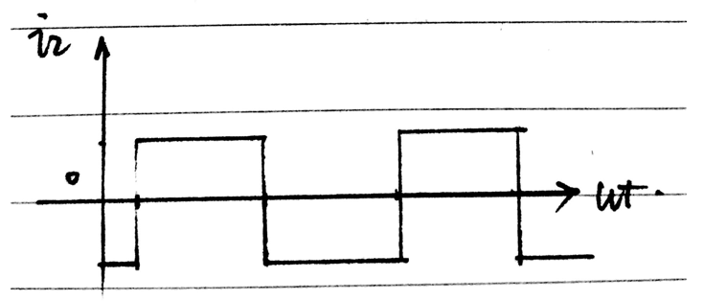

(2).



(3).Ratio voltage and current

As we all know, the ratio voltage and current for the thyristor are larger than the maximum V and I it can stand. As usual, the time of ratio voltage to the maximum V is 2~3, and for the current is 1.5~2.

So :



3.6 A single-phase bridge half-controlled rectifier is shown in figure 3-12. U2=200V, the load is resistive and inductive, R=2Ω, L is extremely large. When α = 60°, try to compute the effective value(RMS value) of current flowing through devices, and plot the waveform of ***ud***, ***id*** , ***iVT*** and ***iVD***.



Figure 3-12. Single-phase bridge half-controlled rectifier

